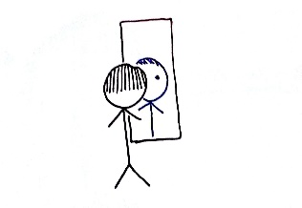
Fascinating facts about Me: ___________________________________
This Photo by Unknown Author is licensed under CC BY
I am _______ years old. I am in the __________ grade.
The members of my family are:

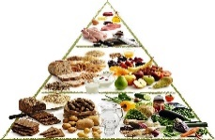 My favorite food is _______________________________________________
This Photo by Unknown Author is licensed under CC BY-NC
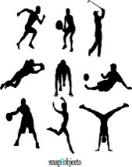 My favorite sport is _________________________________________________
This Photo by Unknown Author is licensed under CC BY

My favorite TV show is ________________________________________________
This Photo by Unknown Author is licensed under CC BY-SA

My favorite song is __________________________________________________

Author is licensed under CC BY-SA
My favorite school activity is _________________________________________
This Photo by Unknown Author is licensed under CC BY-NC-ND
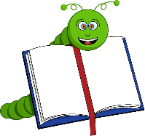If you write a book, what would it be about? ______________________________________________________________________________________________

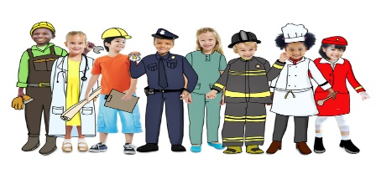 What is your dream job? ______________________________
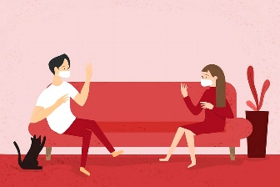 How well are you handling ‘social distancing’? _______________________________________________________________________________
_______________________________________________________________________________

How do you feel about ‘virtual’ education?

_____________________________________________________________________________

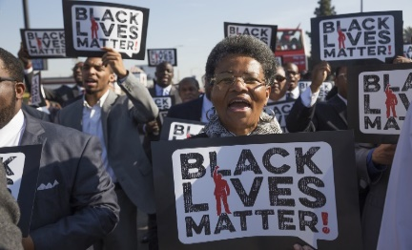
Why do Black Lives Matter?
This Photo by Unknown Author is licensed under CC BY-ND
________________________________________________________________________
________________________________________________________________________
_____________________________________________________________________________________________________

